Providing Content Interface PDF documents

# Why?

The Content Interface is designed to generate interactive online pages that take full advantage of the web environment. There are times when students will not have online access. How do you provide them access to the content they can use offline?

## Comparing solutions

### What about providing the original word documents?

Not good. The original Word documents are intended to help with authoring, rather than reading. They are missing the transformations that occur in Blackboard. For example, converting video embed code into playable video; provision of specific University dates; course specific styling etc.

### Download PDF – a better solution

The *Download PDF* option not only retains the transformations that occur in Blackboard it makes additional transformations to aid offline and print use. For example: the addition of page numbers; conversion of embedded video players into links to relevant videos; and, the addition of sections listing all the links in a document.

# What?

Once configured the PDF option adds a *Download PDF* option to the Content Interface page (Figure 1). When the *Download PDF* button is clicked, the content is transformed for offline use and the browser’s and operating system’s [“print to PDF” feature](https://blog.pcrisk.com/windows/11978-how-to-print-to-pdf) to produce a PDF version of the page (Figure 2).

## What is looks like in Blackboard

Figure 1 shows a Content Interface page with the *Download PDF* option enabled. Note the **Download PDF** button at the top of the page next to the **Expand All** and **Collapse All** buttons.

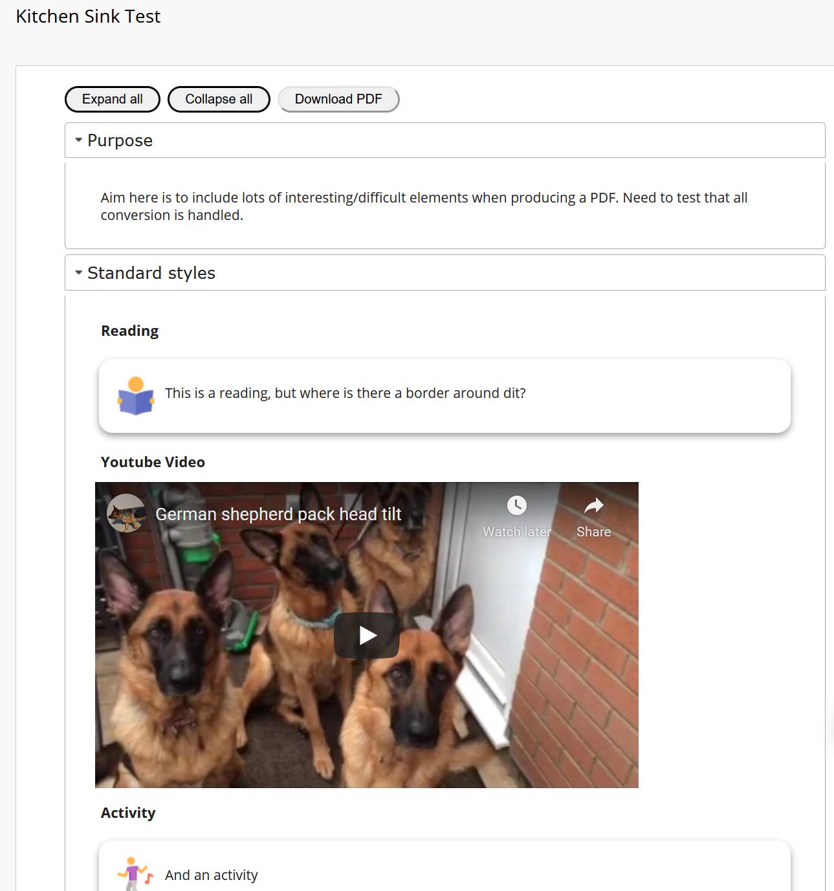

Figure 1 - Example Content Interface with the "Download PDF" option

## What it looks like as a PDF document

Figure 2 shows parts of the PDF version of Figure 1.

The name of the course site (*David Jones Sandpit*) has been added above the page title (*Kitchen Sink Test*).

The *Youtube Video* section has been converted from the embedded, playable video when viewed online, into a message and a link to the YouTube video.

Figure 3 shows the *Online Exclusive Materials* section that is added to the end of each PDF (as appropriate). This section lists the external links included in the document. This allows the reader to make decisions about which of these to download.

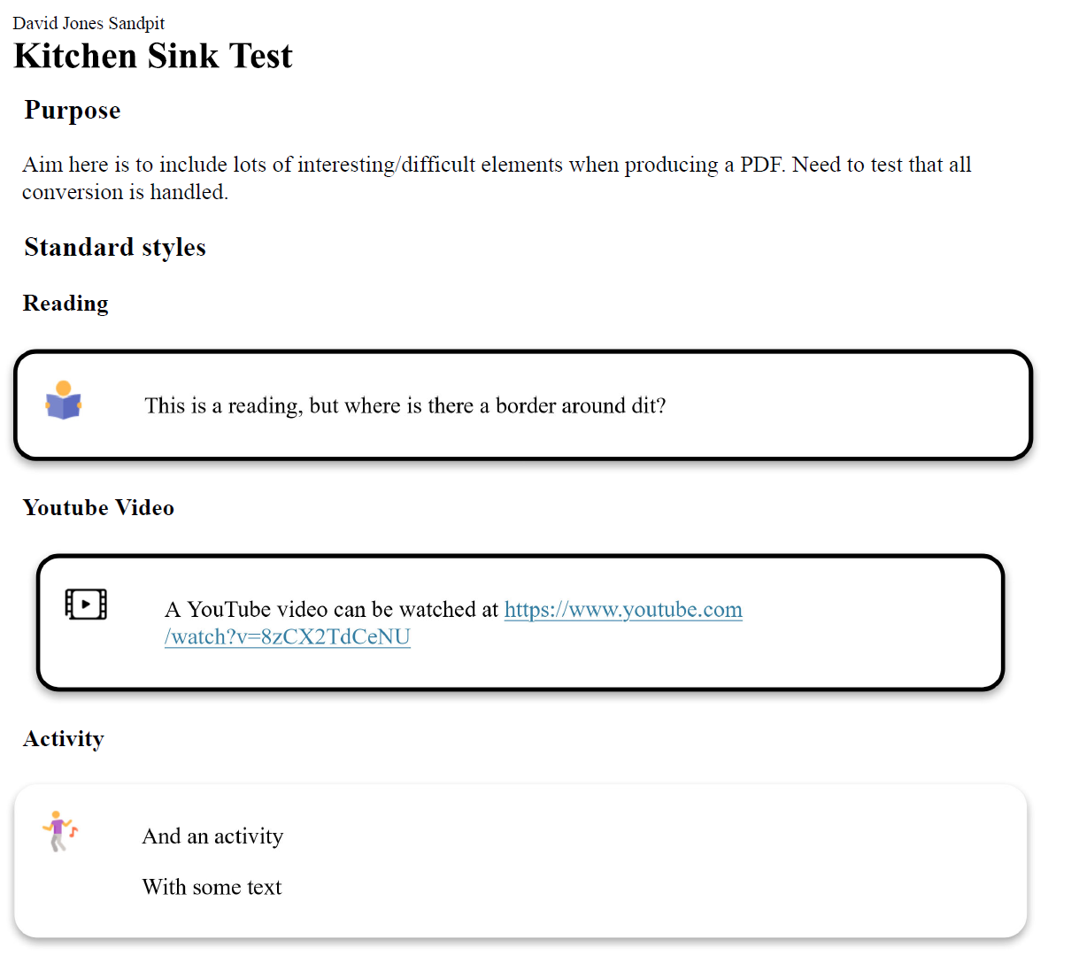

Figure 2 - The PDF version of the Content Interface shown in Figure 1

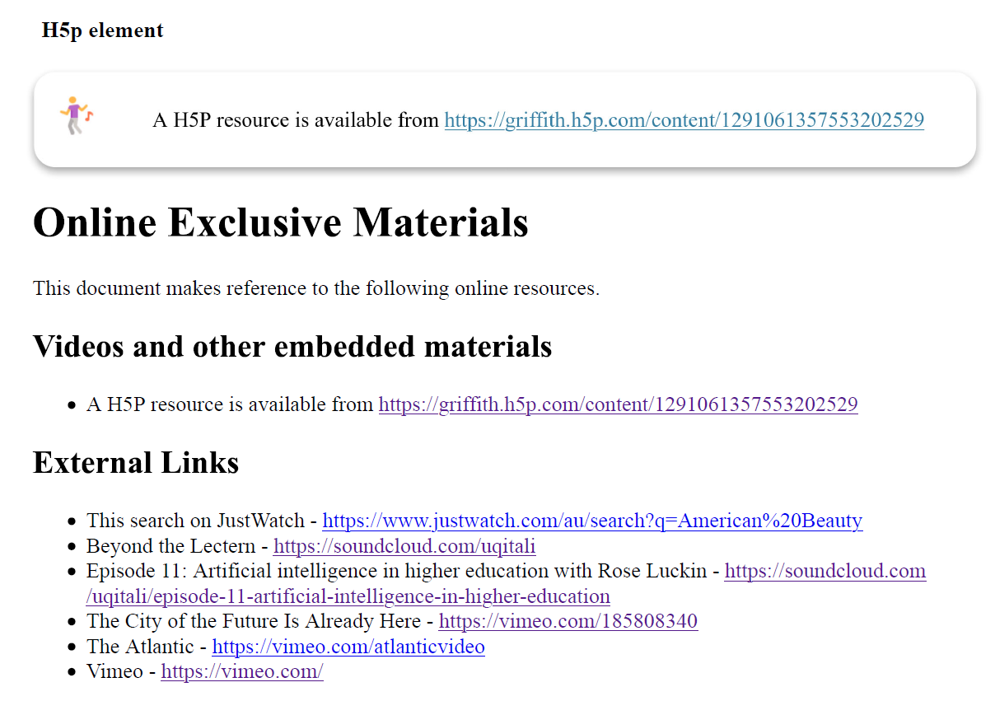

Figure 3 - The PDF's "Online Exclusive Materials" section

# How?

You enable the *Download PDF* option by adding **downloadPDF** to the name of the *Content Interface* item in Blackboard.

Figure 4 below shows a *Content Interface* item being edited and **downloadPDF** added. Figure 5 shows the Blackboard page containing the *Content Interface* item with *Edit Mode* on. With *Edit Mode* on you can see the added **downloadPDF**. With *Edit Mode* off, the whole name disappears.

|  |  |
| --- | --- |
| Figure 4 - Editing Content Interface item to add **downloadPDF** | Figure 5 - **Edit Mode** on viewing page with **downloadPDF** added to Content Interface item |

# Known limitations and possible issues

The **downloadPDF** option is a new addition. To work it must deal with the differences that exist between browsers and content. Hence there are some known limitations and likely some possible issues. Some of which are outlined here.

## downloadPDF relies on your device’s operating system and your browser

The **downloadPDF** option produces a new web page and then asks your browser to print that new page. At this stage, most contemporary devices and their operating systems [provide ways to print to PDF](https://www.howtogeek.com/235134/how-to-print-to-pdf-on-any-computer-smartphone-or-tablet/).

## Firefox generated PDF does not have clickable links

For some time, it has been known that the PDF files generated by the Firefox browser does not provide clickable links.

A solution to this is to use other browsers (e.g. Chrome).